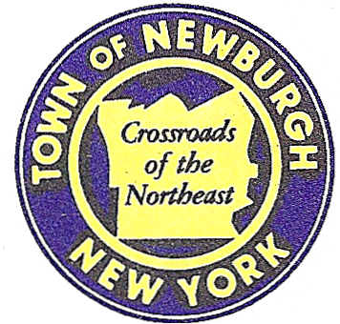

TOWN OF NEWBURGH
_______Crossroads of the Northeast __________________________
OLD TOWN HALL
308 GARDNERTOWN ROAD NEWBURGH, NEW YORK 12550

PLANNING BOARD
JOHN P. EWASUTYN, CHAIRMAN
TELEPHONE 845-564-7804
FAX 845-564-7802
E-MAIL: planningboard@townofnewburgh.org

PLANNING BOARD AGENDA

May 17th, 2018

MEETING CANCELLED

*WORK SESSION*
Project Readiness Discussion scheduled for 6:00 p.m. in the Meeting Room of
Town Hall on Thursday, May 17th, 2018.*

PLANNING BOARD BUSINESS
WORK SESSION

.

*WORK SESSION*
Project Readiness Discussion scheduled for 6:00 p.m. in the Meeting Room of
Town Hall on Thursday, May 17th, 2018.*

